Table Distance Keeper
Version 1.0
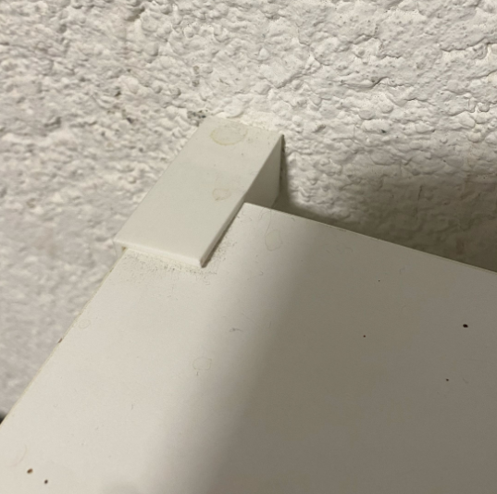

Project Goals
I need a way to prevent the table from swinging back and forth while using it. So I created a spacer that keep the distance from the table to the wall constant.

Table Distance Keeper Sketch
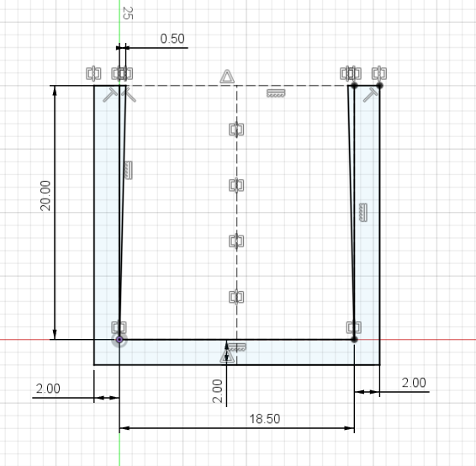

Table Distance Keeper 3D Model
Total extrusion height: 50 mm, 25 mm empty and 25 mm full.
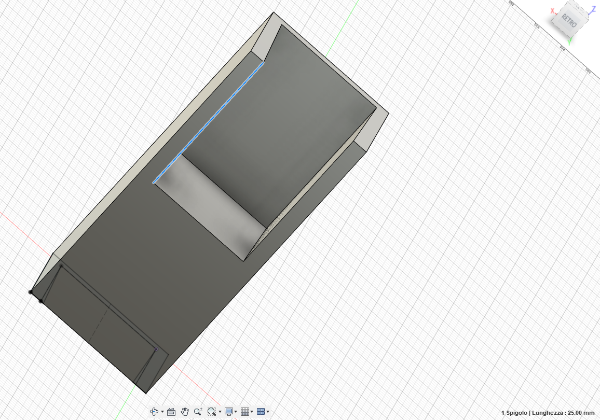

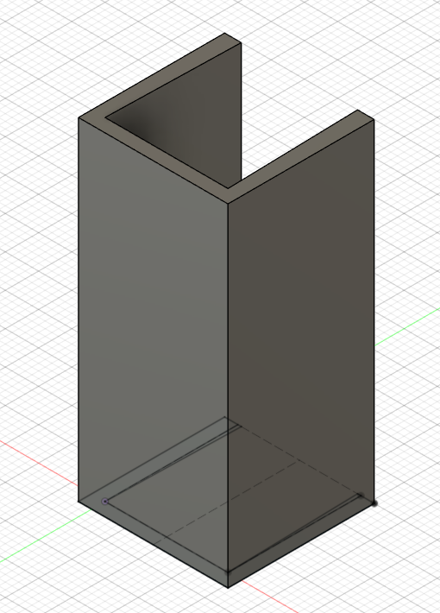

3D Printer layout

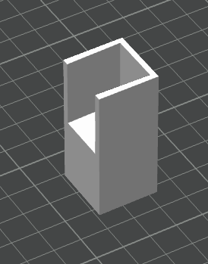

Final result
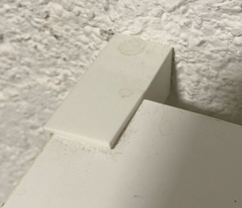 | 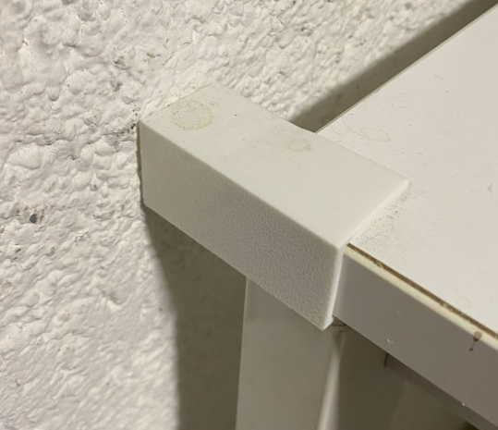 | 